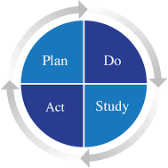
KENTUCKY REC PDSA WORKSHEET

Team Name: | Date: | PDSA Completion Date:
What do you want to improve and by how much? Set a Goal:
How will you know that the change is an improvement? Select Measures:
What changes can lead to improvement?

PLAN:
Briefly describe the test. Is the test doable?

How will you know that the change is an improvement? What are your measures? What do you predict will happen?

List the tasks necessary to complete this test (what) | Person responsible  (who) | When | Where
3.
4.
5.
6.

How will we collect data for assessment/study?
DO: Test the changes. Record data and observations.

Did the test go as planned? Yes ◻ No

What did you observe that was not part of the plan?

STUDY:
Did the results match your predictions?  Yes ◻ No

Compare the result of your test to your previous performance. What did you learn?

ACT: Decide to Adopt, Adapt, or Abandon.
Adapt: Improve the change and continue testing plan. Plans/changes for next test: Refine report with more up-to-date patient information and form changes to pull data.
- Adopt: Select changes to implement on a larger scale and develop an implementation plan and plan for sustainability.
- Abandon: Discard this change idea and try a different one

